***PAAREES PERFUMES***

***VERSACE***

***FOR WOMEN***

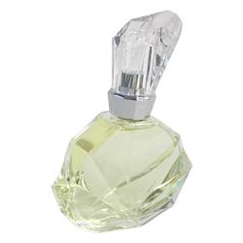

# 

# *Versace Exciting*

# *Description:*

Versace Exciting by Versace Perfume. Get yourself noticed with a splash of Versace Exciting fragrance for women. This exhilarating yet feminine scent was launched by prestigious design house Versace in 2000. Its stunning bouquet features a heady combination of green notes, with zesty and floral accents of grapefruit, lily, freesia and peach, expertly combined to create a delicious aroma that's good enough to eat. This fragrance is ideal for daytime wear, so apply some for the office or a lunch date with someone special.